115 Strange Street
Kitchener
519-743-3702
warrengreenhouses@hotmail.com

Spring 2024

With spring just around the corner, pansy fund-raising is a great way to raise money for your organization.
Pansies are tolerant to cooler weather and can be enjoyed outside beginning in April. You may choose your delivery date anytime between April 5th and 20th. Please have all completed orders to us no later than March 22nd.

Please be advised that your delivery date may be changed due to inclement weather.
There is a 100 pot minimum to qualify for free delivery within a 60km radius. If you are beyond the radius, contact us for a delivery fee estimate.

Pansy Pots are available in MIXED only, in the following sizes.

8” Round Decorative Bowl
10” Round Decorative Bowl
11” Cool Wave Pansy Hanging Basket

COST Recommended Selling

8” Pot $8.00 +HST $12.00- $14.00
10” Pot $10.00 +HST $15.00- $17.00
11” Baskets $13.00 +HST $20.00- $22.00

We strive for excellent quality and service. If you encounter any problems, please notify us immediately and we will do our best to rectify the situation.
Any credit inquiries must be made within 48 hours of delivery.

Thank you and good luck!
Sheila

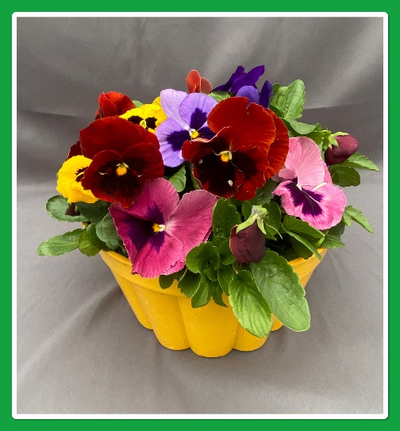
10” Round Pansy Pots
Pot colours may vary

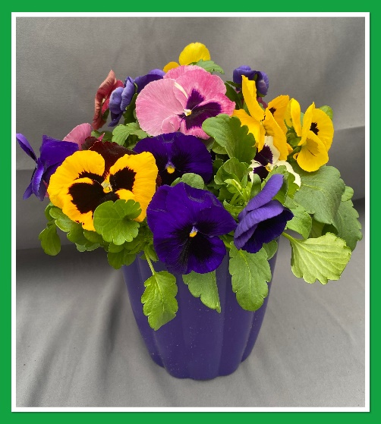
8” Round Pansy Pots
Pot colours may vary

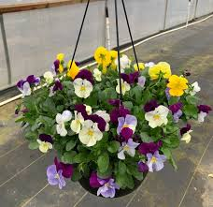
11” Cool Wave Pansy Baskets

Mixed consists of mainly yellows, purples and whites

WARREN GREENHOUSES LTD.
FUNDRAISING SIGNUP SHEET

GROUP NAME____________________________________________

CONTACT NAME_________________________________________

DELIVERY DATE_________________________________________

DELIVERY ADDRESS_____________________________________

CITY__________________________ POSTAL__________________

BILLING ADDRESS _______________________________________

CITY__________________________ POSTAL__________________

PHONE NUMBER ___________________________
___________________________

EMAIL _____________________________________

I ________________________________ Will be the contact person for the above-named organization and therefore will be responsible for making payment within 30 days of my delivery. 2% interest will be added to overdue invoices. We accept cheque, cash or e-transfer.

SIGNATURE_______________________________

DATE_____________________________________

